Contenido
Paso 1: Crear una cuenta de Azure 1
Paso 2: Crear un recurso Face API 1
Paso 3: Obtener las credenciales del servicio Face API 4
Paso 4: Usar el servicio Face API 6

Paso 1: Crear una cuenta de Azure
El primer paso es crear una cuenta de Azure si aún no tienes una. Para ello, puedes visitar el sitio web de Azure (https://azure.microsoft.com) y seguir los pasos indicados para crear una cuenta gratuita o de pago según tus necesidades.

Paso 2: Crear un recurso Face API
Una vez que tengas una cuenta de Azure, debes crear un recurso de Face API en el portal de Azure. Para ello, sigue estos pasos:
- Inicia sesión en el portal de Azure (https://portal.azure.com/).
- Haz clic en el botón "Crear un recurso" en la barra de navegación izquierda.
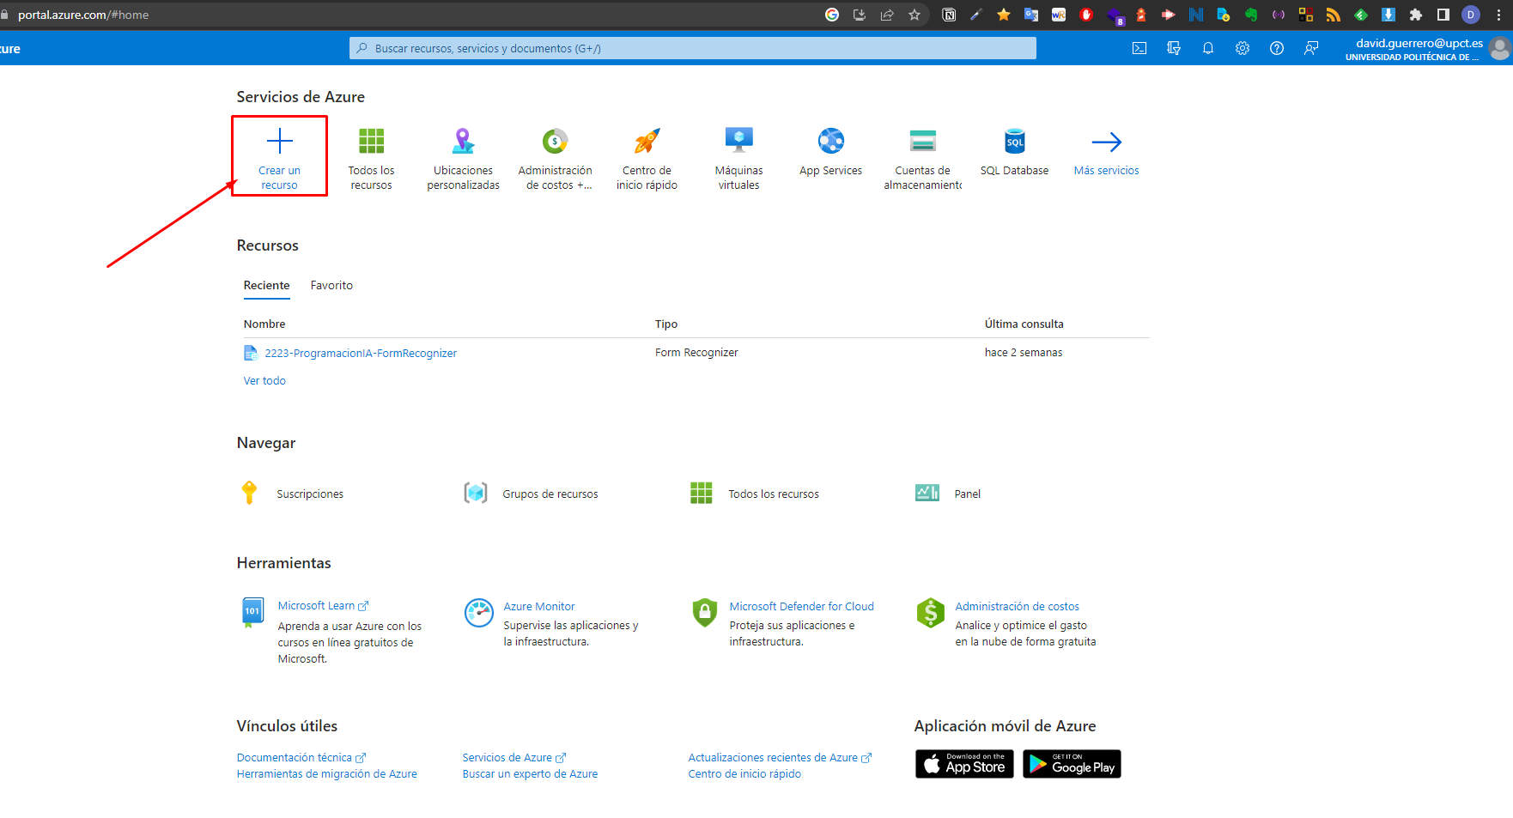
- Busca "Face" en el cuadro de búsqueda y selecciona "Face" de la lista de servicios sugeridos.
- Haz clic en el botón "Crear" en la página de descripción general del servicio Face.
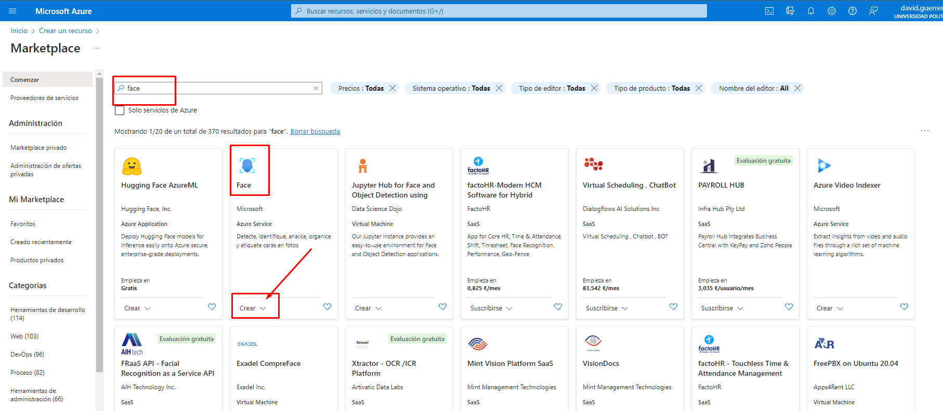
- En la página "Crear", completa los campos requeridos, como el nombre del recurso, el grupo de recursos y la ubicación.
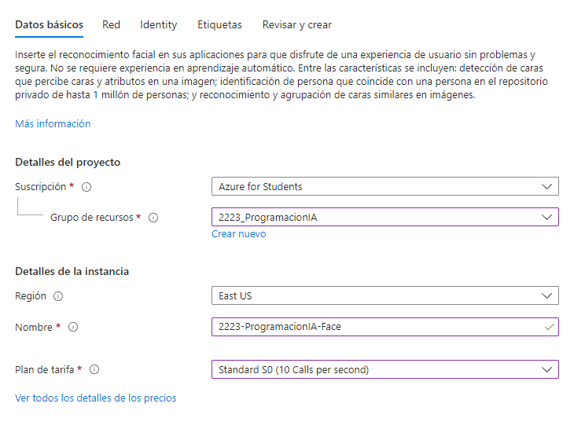
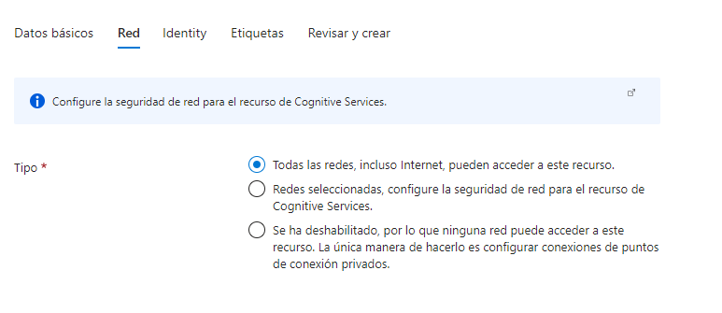

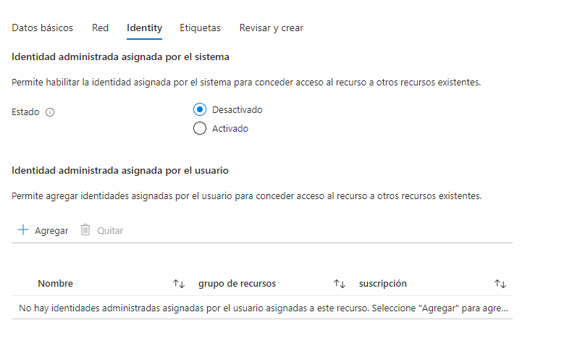

- Haz clic en el botón "Revisar y crear" y, después, en "Crear".
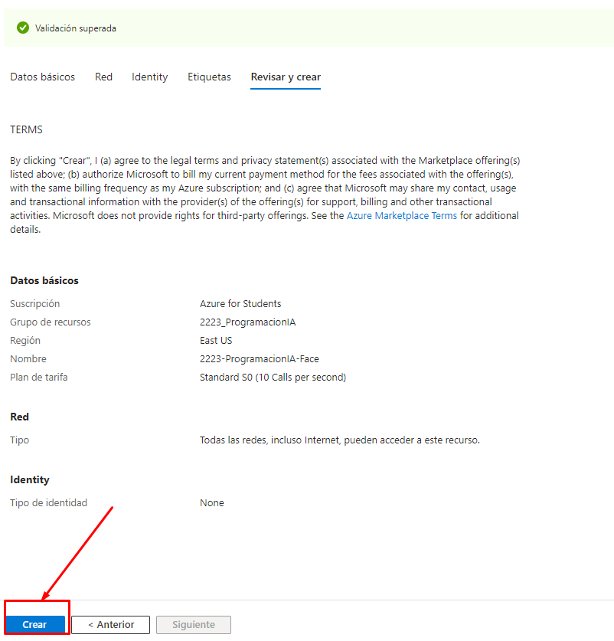
El proceso de creación del recurso puede tardar unos minutos en completarse.

Paso 3: Obtener las credenciales del servicio Face API
Una vez que se haya creado el recurso de Face API, debes obtener las credenciales necesarias para acceder al servicio. Para ello, sigue estos pasos:
- En el portal de Azure, abre la página del recurso de Face API que creaste en el paso anterior.
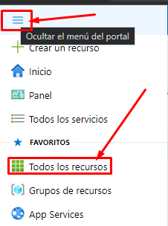

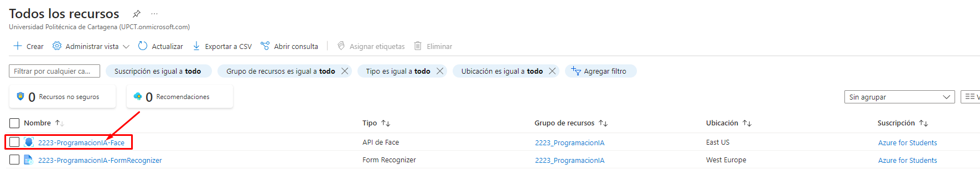
- Haz clic en la pestaña "Claves y punto de conexión".
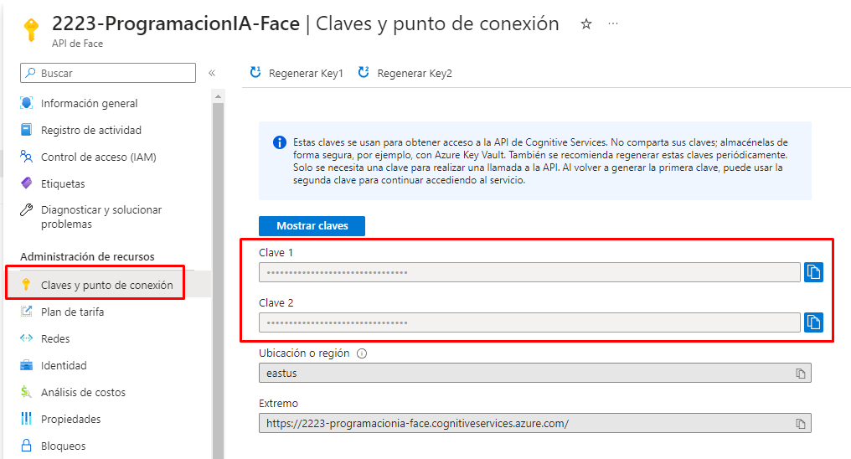
- Copia la clave primaria y el punto de conexión de la sección "Claves".
Guarda estas credenciales en un lugar seguro ya que las necesitarás más adelante para utilizar el servicio Face API.

Paso 4: Usar el servicio Face API
Ahora que tienes las credenciales del servicio Face API, puedes comenzar a utilizarlo. Hay varias formas de hacerlo, pero aquí te mostramos un ejemplo sencillo de cómo detectar caras en una imagen utilizando C#.
using System;
using System.Collections.Generic;
using System.IO;
using System.Linq;
using System.Threading;
using System.Threading.Tasks;

using Microsoft.Azure.CognitiveServices.Vision.Face;
using Microsoft.Azure.CognitiveServices.Vision.Face.Models;

namespace FaceQuickstart
{
class Program
{
static string personGroupId = Guid.NewGuid().ToString();

// URL path for the images.
const string IMAGE_BASE_URL = "https://raw.githubusercontent.com/Azure-Samples/cognitive-services-sample-data-files/master/Face/images/";

// From your Face subscription in the Azure portal, get your subscription key and endpoint.
const string SUBSCRIPTION_KEY = "PASTE_YOUR_FACE_SUBSCRIPTION_KEY_HERE";
const string ENDPOINT = "PASTE_YOUR_FACE_SUBSCRIPTION_ENDPOINT_HERE";

static void Main(string[] args)
{
// Recognition model 4 was released in 2021 February.
// It is recommended since its accuracy is improved
// on faces wearing masks compared with model 3,
// and its overall accuracy is improved compared
// with models 1 and 2.
const string RECOGNITION_MODEL4 = RecognitionModel.Recognition04;

// Authenticate.
IFaceClient client = Authenticate(ENDPOINT, SUBSCRIPTION_KEY);

// Identify - recognize a face(s) in a person group (a person group is created in this example).
IdentifyInPersonGroup(client, IMAGE_BASE_URL, RECOGNITION_MODEL4).Wait();

Console.WriteLine("End of quickstart.");
}

/*
* AUTHENTICATE
* Uses subscription key and region to create a client.
*/
public static IFaceClient Authenticate(string endpoint, string key)
{
return new FaceClient(new ApiKeyServiceClientCredentials(key)) { Endpoint = endpoint };
}

// Detect faces from image url for recognition purposes. This is a helper method for other functions in this quickstart.
// Parameter `returnFaceId` of `DetectWithUrlAsync` must be set to `true` (by default) for recognition purposes.
// Parameter `FaceAttributes` is set to include the QualityForRecognition attribute.
// Recognition model must be set to recognition_03 or recognition_04 as a result.
// Result faces with insufficient quality for recognition are filtered out.
// The field `faceId` in returned `DetectedFace`s will be used in Face - Face - Verify and Face - Identify.
// It will expire 24 hours after the detection call.
private static async Task<List<DetectedFace>> DetectFaceRecognize(IFaceClient faceClient, string url, string recognition_model)
{
// Detect faces from image URL. Since only recognizing, use the recognition model 1.
// We use detection model 3 because we are not retrieving attributes.
IList<DetectedFace> detectedFaces = await faceClient.Face.DetectWithUrlAsync(url, recognitionModel: recognition_model, detectionModel: DetectionModel.Detection03, returnFaceAttributes: new List<FaceAttributeType> { FaceAttributeType.QualityForRecognition });
List<DetectedFace> sufficientQualityFaces = new List<DetectedFace>();
foreach (DetectedFace detectedFace in detectedFaces){
var faceQualityForRecognition = detectedFace.FaceAttributes.QualityForRecognition;
if (faceQualityForRecognition.HasValue && (faceQualityForRecognition.Value >= QualityForRecognition.Medium)){
sufficientQualityFaces.Add(detectedFace);
}
}
Console.WriteLine($"{detectedFaces.Count} face(s) with {sufficientQualityFaces.Count} having sufficient quality for recognition detected from image `{Path.GetFileName(url)}`");

return sufficientQualityFaces.ToList();
}

/*
* IDENTIFY FACES
* To identify faces, you need to create and define a person group.
* The Identify operation takes one or several face IDs from DetectedFace or PersistedFace and a PersonGroup and returns
* a list of Person objects that each face might belong to. Returned Person objects are wrapped as Candidate objects,
* which have a prediction confidence value.
*/
public static async Task IdentifyInPersonGroup(IFaceClient client, string url, string recognitionModel)
{
Console.WriteLine("========IDENTIFY FACES========");
Console.WriteLine();

// Create a dictionary for all your images, grouping similar ones under the same key.
Dictionary<string, string[]> personDictionary =
new Dictionary<string, string[]>
{ { "Family1-Dad", new[] { "Family1-Dad1.jpg", "Family1-Dad2.jpg" } },
{ "Family1-Mom", new[] { "Family1-Mom1.jpg", "Family1-Mom2.jpg" } },
{ "Family1-Son", new[] { "Family1-Son1.jpg", "Family1-Son2.jpg" } },
{ "Family1-Daughter", new[] { "Family1-Daughter1.jpg", "Family1-Daughter2.jpg" } },
{ "Family2-Lady", new[] { "Family2-Lady1.jpg", "Family2-Lady2.jpg" } },
{ "Family2-Man", new[] { "Family2-Man1.jpg", "Family2-Man2.jpg" } }
};
// A group photo that includes some of the persons you seek to identify from your dictionary.
string sourceImageFileName = "identification1.jpg";

// Create a person group.
Console.WriteLine($"Create a person group ({personGroupId}).");
await client.PersonGroup.CreateAsync(personGroupId, personGroupId, recognitionModel: recognitionModel);
// The similar faces will be grouped into a single person group person.
foreach (var groupedFace in personDictionary.Keys)
{
// Limit TPS
await Task.Delay(250);
Person person = await client.PersonGroupPerson.CreateAsync(personGroupId: personGroupId, name: groupedFace);
Console.WriteLine($"Create a person group person '{groupedFace}'.");

// Add face to the person group person.
foreach (var similarImage in personDictionary[groupedFace])
{
Console.WriteLine($"Check whether image is of sufficient quality for recognition");
IList<DetectedFace> detectedFaces1 = await client.Face.DetectWithUrlAsync($"{url}{similarImage}",
recognitionModel: recognitionModel,
detectionModel: DetectionModel.Detection03,
returnFaceAttributes: new List<FaceAttributeType> { FaceAttributeType.QualityForRecognition });
bool sufficientQuality = true;
foreach (var face1 in detectedFaces1)
{
var faceQualityForRecognition = face1.FaceAttributes.QualityForRecognition;
// Only "high" quality images are recommended for person enrollment
if (faceQualityForRecognition.HasValue && (faceQualityForRecognition.Value != QualityForRecognition.High)){
sufficientQuality = false;
break;
}
}

if (!sufficientQuality){
continue;
}

// add face to the person group
Console.WriteLine($"Add face to the person group person({groupedFace}) from image `{similarImage}`");
PersistedFace face = await client.PersonGroupPerson.AddFaceFromUrlAsync(personGroupId, person.PersonId,
$"{url}{similarImage}", similarImage);
}
}

// Start to train the person group.
Console.WriteLine();
Console.WriteLine($"Train person group {personGroupId}.");
await client.PersonGroup.TrainAsync(personGroupId);

// Wait until the training is completed.
while (true)
{
await Task.Delay(1000);
var trainingStatus = await client.PersonGroup.GetTrainingStatusAsync(personGroupId);
Console.WriteLine($"Training status: {trainingStatus.Status}.");
if (trainingStatus.Status == TrainingStatusType.Succeeded) { break; }
}
Console.WriteLine();

List<Guid> sourceFaceIds = new List<Guid>();
// Detect faces from source image url.
List<DetectedFace> detectedFaces = await DetectFaceRecognize(client, $"{url}{sourceImageFileName}", recognitionModel);

// Add detected faceId to sourceFaceIds.
foreach (var detectedFace in detectedFaces) { sourceFaceIds.Add(detectedFace.FaceId.Value); }

// Identify the faces in a person group.
var identifyResults = await client.Face.IdentifyAsync(sourceFaceIds, personGroupId);

foreach (var identifyResult in identifyResults)
{
if (identifyResult.Candidates.Count==0) {
Console.WriteLine($"No person is identified for the face in: {sourceImageFileName} - {identifyResult.FaceId},");
continue;
}
Person person = await client.PersonGroupPerson.GetAsync(personGroupId, identifyResult.Candidates[0].PersonId);
Console.WriteLine($"Person '{person.Name}' is identified for the face in: {sourceImageFileName} - {identifyResult.FaceId}," +
$" confidence: {identifyResult.Candidates[0].Confidence}.");

VerifyResult verifyResult = await client.Face.VerifyFaceToPersonAsync(identifyResult.FaceId, person.PersonId, personGroupId);
Console.WriteLine($"Verification result: is a match? {verifyResult.IsIdentical}. confidence: {verifyResult.Confidence}");
}
Console.WriteLine();
}
}
}

